BACH VESPERS
St Anne’s Lutheran Church
at the Church of St Mary-at-hill, Lovat Lane, London EC3R 8EE
First Sunday in Advent, 27 November 2016 at 18.30

Prelude 'Nun, komm, der Heiden Heiland' BWV 659 | J. S. Bach  (1685-1750)
Chorale prelude BWV 699 | J. S. Bach

Stand as able to sing the Hymn: Saviour of the nations, come

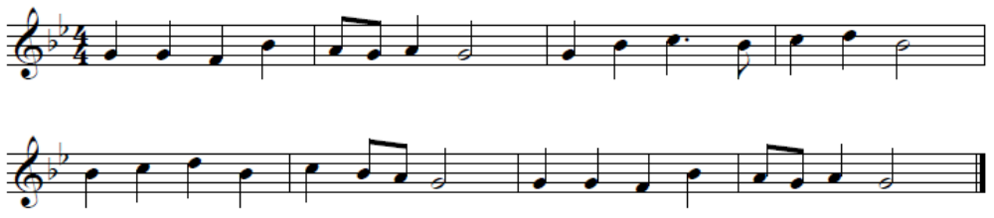

1. Saviour of the nations, come,  Virgin's Son, make here Your home!  Marvel now, O heaven and earth,  That the Lord chose such a birth. | 2. Not by human flesh and blood,  By the Spirit of our God,  Was the Word of God made flesh --  Woman's offspring pure and fresh.

Greeting
The grace of our Lord Jesus Christ, the love of God,
And the communion of the Holy Spirit be with you all.
(all say) And also with you

Psalm | Psalm 24
(said responsively; all say text in bold)

The earth is the Lord’s, and everything in it,
the world, and all who live in it;
for he founded it on the seas
and established it on the waters.
Who may ascend the mountain of the Lord?
Who may stand in his holy place?
The one who has clean hands and a pure heart,
who does not trust in an idol
or swear by a false god.
They will receive blessing from the Lord
and vindication from God their Savior.
Such is the generation of those who seek him,
who seek your face, God of Jacob.
Lift up your heads, you gates;
be lifted up, you ancient doors,
that the King of glory may come in.
Who is this King of glory?
The Lord strong and mighty,
the Lord mighty in battle.
Lift up your heads, you gates;
lift them up, you ancient doors,
that the King of glory may come in.
Who is he, this King of glory?
The Lord Almighty—
he is the King of glory.

Stand as able for the Collect of the Day - all say Amen

Sit for the Chorale Prelude Vater Unser In Himmelreich,  BWV 636 from Orgelbüchlein | J. S. Bach

All stand as able to sing The Lord’s Prayer
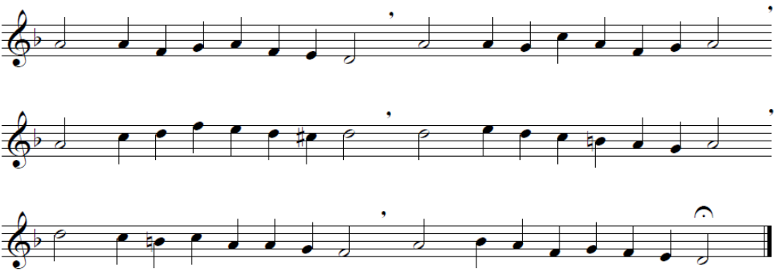

1. Our Father, Lord of heaven and earth,  let praise and honour clothe your name.  Your kingdom come, your will be done;  throughout the world complete your reign.  Teach us, O Lord, to trust in you  for bread and breath each day anew. | 2. Forgive us, Lord, our sins and debts  as we to debtors show your grace.  Remove us from all tempting paths  and guard us from the devil's ways;  for glory, strength, and heaven's throne  belong to you, and you alone. Amen.

Sit for The First Reading | Romans 13: 11-14

The Creed: Wir gläuben all an einen Gott | Andreas Raselius  (c. 1563 - 1602)
1st verse, sung by the choir:

Wir gläuben all an einen Gott,  Schöpfer Himmels und der Erden,  der sich zum Vater geben hat,  dass wir seine Kinder werden.  Er will uns allzeit ernähren,  Leib und Seel auch wohl bewahren;  allem Unfall will er wehren,  kein Leid soll uns widerfahren.  Er sorget für uns, hüt’ und wacht;  es steht alles in seiner Macht. | We all believe in one true God,  Who created earth and heaven,  The Father, who to us in love  Hath the right of children given.  He both soul and body feedeth,  All we need He doth provide us;  He through snares and perils leadeth,  Watching that no harm betide us.  He careth for us day and night,  All things are governed by His might.

Stand as able to sing verses 2 & 3 (overleaf)
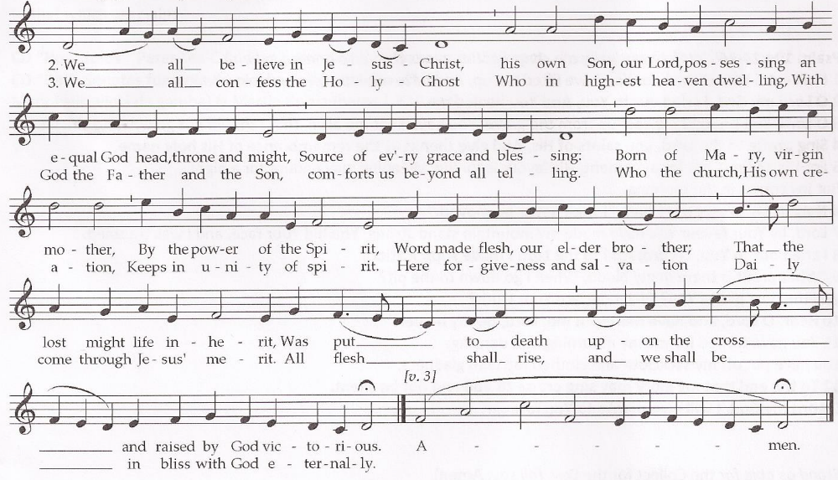

Sit for the Gospel | Matthew 21: 1-9

The Sermon Introduction
Grace and peace to you from God our Father and from the Lord Jesus Christ.

The Sermon Hymn (sung by the choir) BWV 332 | J.S. Bach
Herr Jesu Christ! dich zu uns wend,  Dein' Heil'gen Geist du zu uns send:  Mit Hilf' und Gnad', er uns regier  Und uns den Weg zur Wahrheit führ. | Lord Jesus Christ! Turn towards us,  send your Holy Spirit to us:  with her help and grace may he rule us  and lead us on the way to truth.
The Sermon

Cantata: 'Nun, komm', der Heiden Heiland', BWV 62 | J.S. Bach

Cantata BWV 62 was performed first in Bach Vespers in December 1990, then in 1998, 2008 and 2010. This will be its fifth performance in association with St. Anne's Lutheran Church. See insert for translation.

Stand as able to sing responsively:
Lord, have mercy upon us
Lord, have mercy upon us
Christ, have mercy upon us
Lord, have mercy upon us

The Prayer

Remain standing for the Responses (sung by the choir) | Peter Lea-Cox  (1945-)

The Collect for Peace - all say Amen

Sit for the Offering: Herr nun läßt du deinen Diener, BuxWV 37 | Dietrich Buxtehude  (1637-1707)

Stand as able for the Blessing - all say Amen

Announcements

Postlude Fantasia (1715) | Gottfried Finger  (1656-1730)
Remain in silence until the candles are extinguished

Announcements

We welcome new visitors and old friends to this Bach Vespers service of St. Anne's Lutheran Church at St. Mary-at-Hill. You are warmly invited to stay for refreshments and a chat at the end of the service.

Participants in this service:
Presiding Minister & Preacher: The Rev'd Eliza Zikmane | Lector: Trevor Broomhill

Music provided by the City Bach Collective, citybachcollective.org.uk

CHOIR  Soprano: Emily Atkinson  Alto: Patricia Hammond  Tenor: David Lee  Bass: Cheyney Kent | INSTRUMENTALISTS  Violins: Hazel Brooks (leader), Philip Yeeles  Viola: Geoff Irwin  Cello: Mary Pells  Bass: Peter McCarthy  Oboes: Belinda Paul, Gerry McDonald  Horn: Julia MacDonell  Organ: Simon Lloyd

St. Anne's Lutheran Church gratefully acknowledges the support of Gibson Dunn for Bach Vespers

Bach Vespers is supported by Music-at-Hill, formerly St. Anne's Music Society
For details of Music-at-Hill's lunchtime recitals, please see the brochure. musicathill.org.uk

Gift Aid If you have forgotten your offering envelope please take a St. Anne's Lutheran Church envelope from the basket at the rear of the church and write on it your name and the date. Only in this way can we reclaim the tax you have already paid. Please advise us if you no longer pay an amount of income tax and/or capital gains tax equal to that which we claim.

St Anne’s Lutheran Church
at the Church of St Mary-at-Hill, Lovat Lane, London EC3R 8EE
www.StAnnesLutheranChurch.org.uk

